Zero Trust Network Access (ZTNA) with Zscaler: Zero Trust network access :
Providing Safe and Direct Access to Applications

S.No | NAME | COLLEGE NAME | CONTACT
1. | HARIPRIYA K | SRI KRISHNA ADITHYA COLLEGE OF ARTS AND SCIENCE | 23bscs215haripriyak@skacas.ac.in
2. | LAKSHMANAN R | SRI KRISHNA ADITHYA COLLEGE OF ARTS AND SCIENCE | 23bscs223lakshmananr@skacas.ac.in
3. | MANIKANDAN B | SRI KRISHNA ADITHYA COLLEGE OF ARTS AND SCIENCE | 23bscs228manikandanb@skacas.ac.in
4. | MOHAMMED HARIS H | SRI KRISHNA ADITHYA COLLEGE OF ARTS AND SCIENCE | 23bscs231mohammedharish@skacas.ac.in
5. | NITHISH P | SRI KRISHNA ADITHYA COLLEGE OF ARTS AND SCIENCE | 23bscs235nithishp@skacas.ac.in

Project details

Title: Zero Trust Network Access (ZTNA) with Zscaler Zero Trust network access :
Providing Safe and Direct Access to Applications

AI-Enhanced User Protection (AIUP)

AI-Enhanced User Protection (AIUP) is a next-generation security framework that leverages artificial intelligence and machine learning to verify user identities and protect online platforms from cyber threats. Unlike traditional security measures that rely on static credentials like passwords or even two-factor authentication (2FA), AIUP continuously analyzes user behavior to create a dynamic, evolving "trust score" for each individual.

AIUP is essential for modern online security because it addresses the limitations of perimeter-based defenses. As cyber threats become more sophisticated—with attackers using stolen credentials, phishing, and social engineering—relying solely on "what you know" (passwords) or "what you have" (tokens) is no longer sufficient. AIUP adds a third, continuous layer: "who you are" based on how you behave. This system helps organizations prevent account takeovers, reduce fraud, and ensure that the person interacting with a platform is genuinely who they claim to be, throughout their entire session.

The AIUP framework operates by investing massive datasets from various telemetry sources, including device hardware signatures, geolocation history, and network metadata. By establishing a "behavioral baseline" for every user, the system can detect subtle deviations that traditional rule-based systems would miss. For instance, if a user suddenly attempts to download an unusually large volume of data or accesses the application at an irregular hour from an unrecognized IP address, the AI engine instantly triggers a "Step-up Authentication" challenge. This proactive approach ensures that security is not just a gate at the beginning of a session, but a continuous, invisible monitor that adapts to the risk level of every single action performed within the application environment.

Abstract:

The limitations of legacy VPN architectures in addressing modern security threats, particularly lateral movement and over-privileged network access, necessitate a paradigm shift towards Zero Trust principles. This project details the comprehensive design, deployment, and management of a Zero Trust Network Access (ZTNA) solution. By prioritizing safe and direct access to applications, the project aims to replace broad, network-level access with application-specific, identity-driven connectivity.

A critical advantage of this ZTNA implementation is the abstraction of the internal network topology from the end-user. By utilizing "Inside-Out" connectivity, where the internal App Connectors establish outbound calls to the cloud broker, the organization effectively eliminates the need for listening ports on the external firewall. This "Dark Cloud" architecture ensures that even if an attacker scans the institution's public IP range, they will find no entry points to exploit.

The integration of adaptive access policies further ensures that security posture is synchronized with the threat landscape; as global threat intelligence (via MISP) identifies new malicious actors, the ZTNA framework can automatically block those entities from reaching the broker, providing a self-healing and defensive perimeter that scales with the institution's growth.

Use Case Scenarios:

Scenario 1: Secure Remote Access for Faculty to ERP System

A faculty member working from home needs to access the university's ERP system to upload student grades. Using ZTNA, they connect securely without being placed on the internal network. The system verifies their identity via MFA and checks their device health before granting access

Output:

User identity verified (Faculty_Group)

Device posture compliant (Encryption enabled, OS up-to-date)

Secure micro-tunnel established to ERP Application only

Network remains completely invisible to the user

Scenario 2: External Researcher Accessing a Specific Database

An external research collaborator from another institution requires temporary access to a single research database. The administrator creates a time-limited, application-specific policy. The researcher accesses only the authorized database without any visibility into the rest of the institutional network

Output:

External user identity verified via temporary guest credentials

Access policy enforced (Time-limited: 14 days, Application: Research-DB only)

Database server remains hidden from internet scanners

Scenario 3: Student Access to Online Examination Portal

During final exams, thousands of students simultaneously access the internal online examination portal from various locations. ZTNA ensures that only authenticated students with compliant devices can reach the exam server. The system prevents DDoS attacks on the login page and blocks any attempts to access other internal resources.

Output:

Mass user authentication handled via cloud-native scalability

Each student connected only to the exam application

Lateral movement to grade databases or other servers blocked

Exam server IP address remains concealed from the public internet

Scenario 4: IT Administrator Performing Server Maintenance

An IT administrator needs to perform critical updates on an internal application server. Instead of connecting via a legacy VPN and gaining full network access, they use ZTNA to connect directly to the specific server's management interface. The session is monitored in real-time.

Output:

Admin identity verified with hardware-based MFA

Direct micro-tunnel to Server-Management-Interface only

All admin keystrokes and commands logged for audit compliance

Attempts to access unauthorized segments are automatically blocked

Scenario 5: Temporary Contractor Access for System Upgrades

A contractor hired for a system upgrade needs temporary access to a specific file server to migrate data. Using ZTNA, the contractor is granted application-specific access without being added to the primary Active Directory or receiving broad VPN credentials.

Output:

Contractor identity verified via separate IdP integration

Access granted to File-Server-Migration share only

All file transfer activities logged in the SIEM for security monitoring
Access automatically revoked after the 30-day project deadline

Stage-1

Title Of the Project:

Zero Trust Network Access (ZTNA): Providing Safe and Direct Access to Applications

Overview :

This project focuses on implementing a Zero Trust Network Access (ZTNA) model to provide secure, safe, and direct access to applications for users regardless of their location. Traditional security models trust users inside the network, but Zero Trust follows the principle of “Never Trust, Always Verify.” Every user and device attempting to access an application must be authenticated, authorized, and continuously validated.

The main objective of this project is to enhance cybersecurity by ensuring that only verified users can access specific applications. The system evaluates user identity, device status, and contextual information before granting access. By implementing Zero Trust architecture, organizations can reduce the risks of unauthorized access, insider threats, and data breaches.

The ZTNA system establishes a secure connection between users and applications without exposing the internal network. Instead of allowing full network access, the system provides application-level access, ensuring users can only reach the applications they are authorized to use. This approach significantly improves security while maintaining user productivity.

A key feature of the system is continuous authentication and monitoring. Even after access is granted, the system continuously checks user behavior, device security posture, and network conditions. If any suspicious activity or policy violation is detected, the system can immediately block access or trigger additional verification steps.

Multi-factor authentication (MFA) is implemented to strengthen security. Users must verify their identity using multiple factors such as passwords, OTPs, or biometric authentication. This ensures that even if one authentication factor is compromised, unauthorized access can still be prevented.

The project also includes device verification and posture assessment. Devices attempting to access applications are checked for security compliance such as updated operating systems, antivirus protection, and secure configurations. Only trusted and compliant devices are allowed to connect to the system.

Secure data transmission is ensured through strong encryption techniques that protect data both in transit and at rest. Security components such as firewalls, intrusion detection systems (IDS), and access control policies are implemented to safeguard sensitive organizational
List of Vulnerability Table:

Practice Website:

S.no | Vulnerability Name | CWE – No
1 | Improper Limitation of a Pathname to a Restricted  Directory | CWE-22
2 | Misconfiguration: Data Transmission Without Encryption | CWE-5 J2EE
3 | Use of Obsolete Function | CWE-447
4 | Weak Encoding for Password | CWE-261
5 | Improper Input Validation | CWE-20
6 | External Control of File Name or Path | CWE-73
7 | Empty Password in Configuration File | CWE-258
8 | Insufficient Verification of Data Authenticity | CWE-345
9 | Improper Output Neutralization for Logs | CWE-117
10 | Generation of Error Message Containing Sensitive Information | CWE-209

REPORT: -

- Vulnerability Name: Improper Limitation of a Pathname to a Restricted Directory
CWE/CVE: CWE-282

OWASP/SANS Category: A01:2025 – Broken Access Control

Description:

In a Zero Trust Network Access (ZTNA) environment, improper validation of file path inputs can allow attackers to perform path traversal attacks. This occurs when an application fails to properly restrict user-supplied file paths, enabling attackers to access files outside the intended directory. If ZTNA-protected applications do not properly validate file paths, attackers may bypass restrictions and access sensitive system files or configuration data.

Business Impact:

Path traversal vulnerabilities can expose confidential data, system configurations, and user information stored in protected directories. In a ZTNA-based system, this may allow unauthorized users to access restricted resources, compromising data confidentiality and system integrity. Such breaches can lead to financial loss, operational disruption, and reputational damage for the organization..

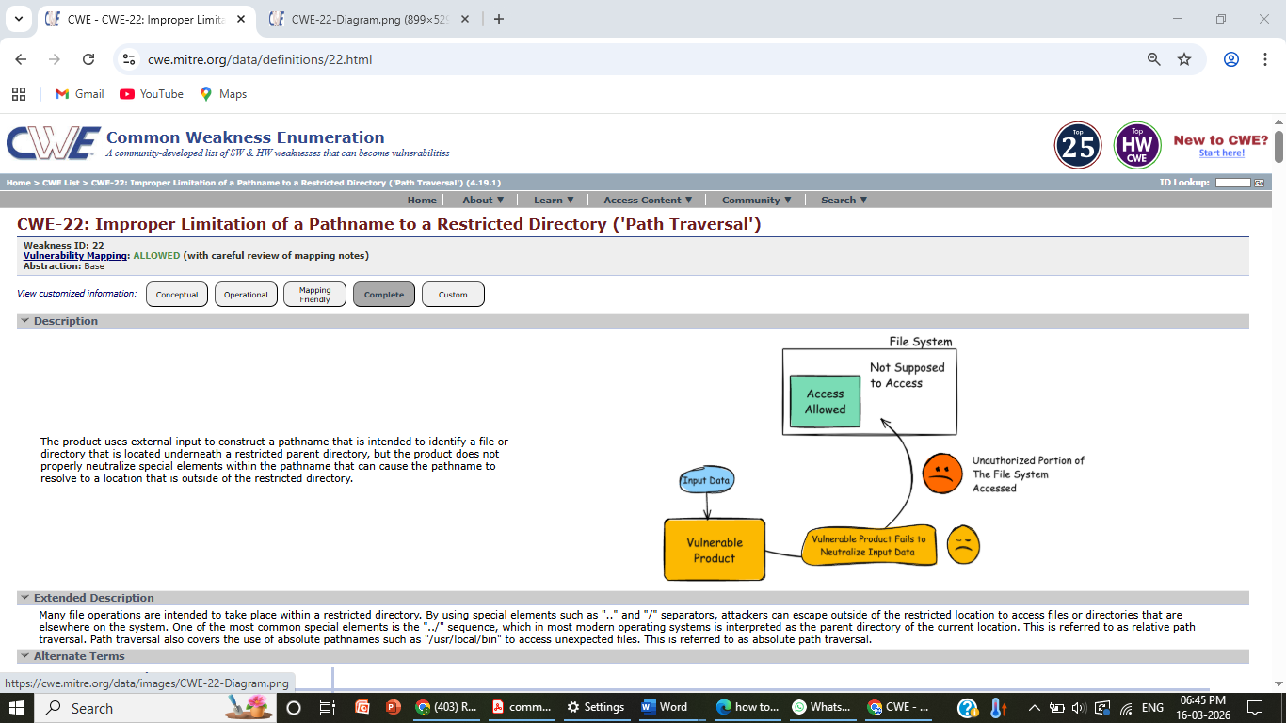

2) Vulnerability Name: Misconfiguration: Data Transmission Without Encryption

CWE/CVE: CWE-5

OWASP/SANS Category: A02:2025-Security Misconfiguration

Description:

In a Zero Trust Network Access (ZTNA) environment, secure communication between users and applications is very important. If a J2EE-based application is misconfigured and transmits data without encryption, sensitive information such as login credentials, session tokens, or user data can travel across the network in plain text. Attackers may intercept this data through network monitoring or man-in-the-middle attacks, which weakens the security model of ZTNA.

Business Impact:
Unencrypted data transmission can lead to exposure of sensitive organizational information and
user credentials. This can allow attackers to gain unauthorized access to protected applications even in a
Zero Trust environment. Such incidents may result in data breaches, financial losses, legal issues, and damage
to the organization’s reputation.

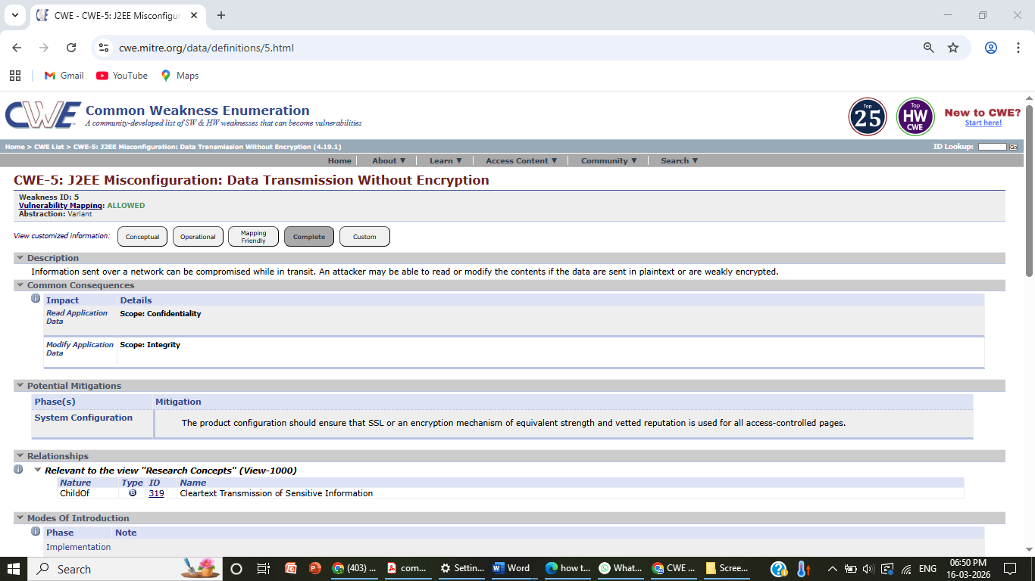

3) Vulnerability Name: Use of Unmaintained Third Party Components

CWE/CVE: CWE-1104

OWASP/SANS Category: A03:2025-Software Supply Chain Failures

Description:
Use of Unmaintained Third Party Components occurs when an application depends on external libraries,
frameworks, or software components that are no longer actively maintained or updated by their developers.
These outdated components may contain known security vulnerabilities that remain unpatched, making the
application susceptible to exploitation. Attackers often scan systems for such components and exploit their
weaknesses to gain unauthorized access, execute malicious code, or compromise the system.

Business Impact:
Using unmaintained third-party components can expose an organization to significant security risks.
Attackers may exploit known vulnerabilities to compromise applications, leading to data breaches, service
disruptions, or unauthorized system access. This can result in financial losses, regulatory compliance issues,
and damage to the organization's reputation. Maintaining updated and supported software components is
therefore essential for ensuring long-term system security.

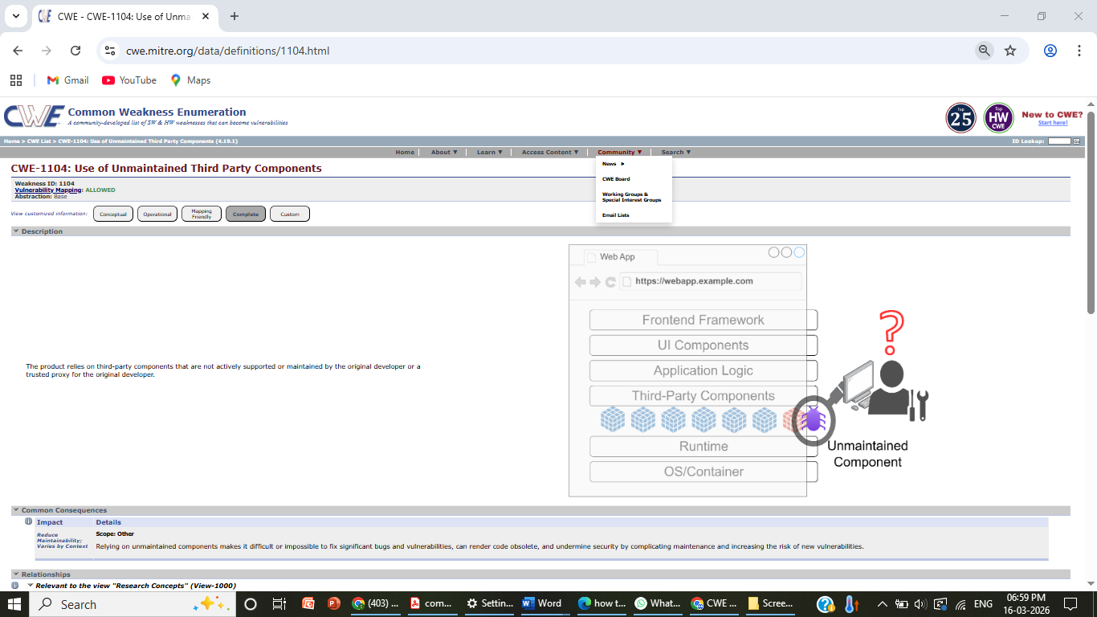

4)Vulnerability Name: Weak Encoding for Password
CWE/CVE: CWE-331
OWASP/SANS Category: A04:2025-Cryptographic Failures
Description:
In a Zero Trust Network Access (ZTNA) environment, applications must use secure and up-to-date functions to maintain strong protection. The use of obsolete or deprecated functions in application code can introduce security weaknesses. These outdated functions may not follow modern security standards and can create vulnerabilities that attackers might exploit to bypass authentication, access controls, or data protection mechanisms in ZTNA-protected applications.
Business Impact:
Using obsolete functions can weaken the security of applications and expose sensitive data to attackers. In a ZTNA-based system, this may allow unauthorized users to exploit vulnerabilities and gain access to protected applications or services. Such security issues can result in data breaches, system compromise, financial loss, and damage to the organization’s reputation.
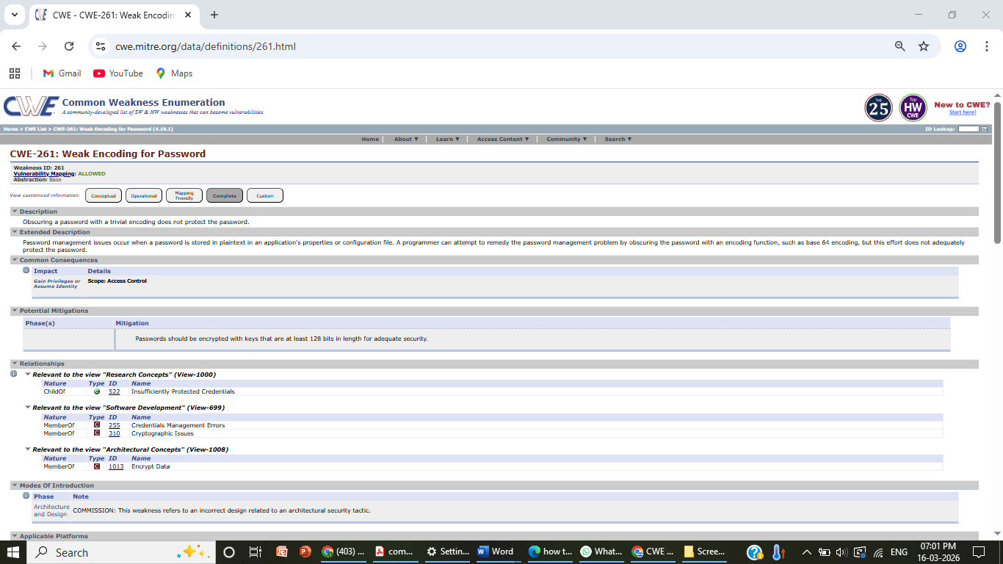

5) Vulnerability Name: Improper Input Validation

CWE/CVE: CWE-391

OWASP/SANS Category: A10:2025-Mishandling of Exceptional Conditions

Description:
In a Zero Trust Network Access (ZTNA) environment, applications must carefully validate all user inputs before processing them. Improper input validation occurs when an application fails to properly check or sanitize the data received from users, devices, or external systems. If ZTNA-protected applications do not validate inputs correctly, attackers may inject malicious data to manipulate application behavior, access unauthorized resources, or disrupt normal operations.

Business Impact

Improper input validation can lead to serious security issues such as unauthorized access, data manipulation, and system compromise. In a ZTNA-based system, attackers may exploit weak input validation to bypass security controls and access sensitive applications or information. This can result in data breaches, operational disruptions, financial losses, and reputational damage for the organization.

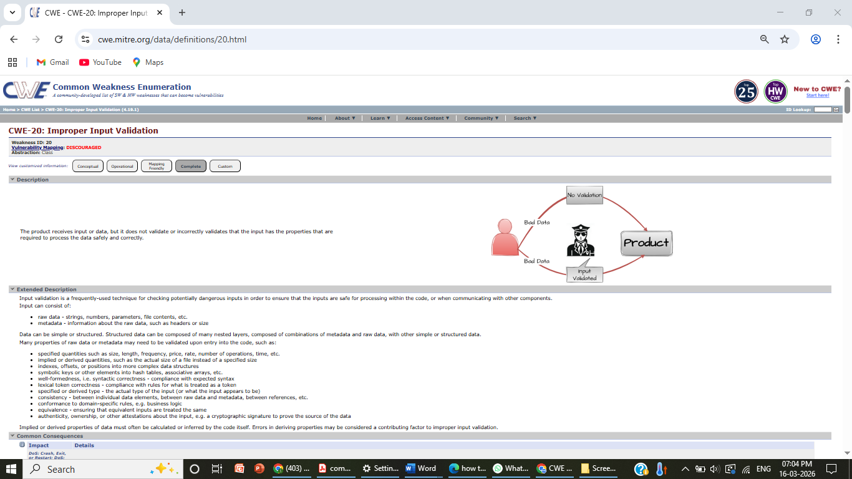

6)Vulnerability Name: External Control of File Name or Path

CWE/CVE: CWE-506

OWASP/SANS Category: A08:2025-Software or Data Integrity Failur
Description:

In a Zero Trust Network Access (ZTNA) environment, applications should strictly control how file names and file paths are handled. This vulnerability occurs when an application allows external users or inputs to directly control the file name or path used in file operations. If ZTNA-protected applications do not properly validate or restrict these inputs, attackers may manipulate file paths to access unauthorized files, overwrite important data, or execute malicious actions within the system.

Business Impact:
External control of file names or paths can expose sensitive files, system configurations, and user data. In a ZTNA-based system, attackers may exploit this weakness to bypass security restrictions and access protected resources. This can lead to data leakage, system compromise, operational disruptions, and financial or reputational damage to the organization..

.
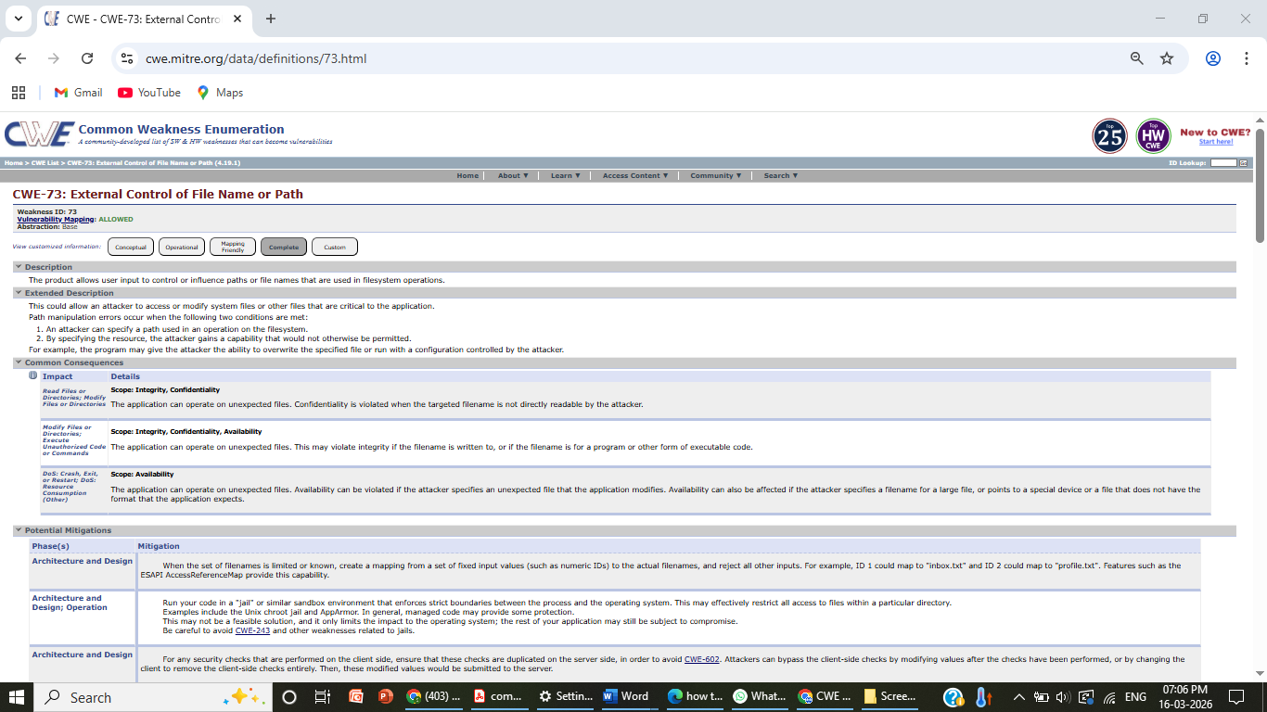
7) Vulnerability Name: Empty Password in Configuration File
CWE/CVE: CWE-311
OWASP/SANS Category: A06:2025-Insecure Design
Description:
In a Zero Trust Network Access (ZTNA) environment, strong authentication and secure configuration are essential to protect applications. This vulnerability occurs when a configuration file contains an account with an empty or blank password. If ZTNA-protected applications are configured with empty passwords, attackers may easily gain unauthorized access to system components, databases, or application services without proper authentication.
Business Impact:
Empty passwords in configuration files can significantly weaken the security of an organization’s systems. In a ZTNA-based environment, attackers may exploit this weakness to access sensitive applications, data, or internal services. This can lead to unauthorized access, data breaches, service disruption, financial loss, and damage to the organization’s reputation.
.

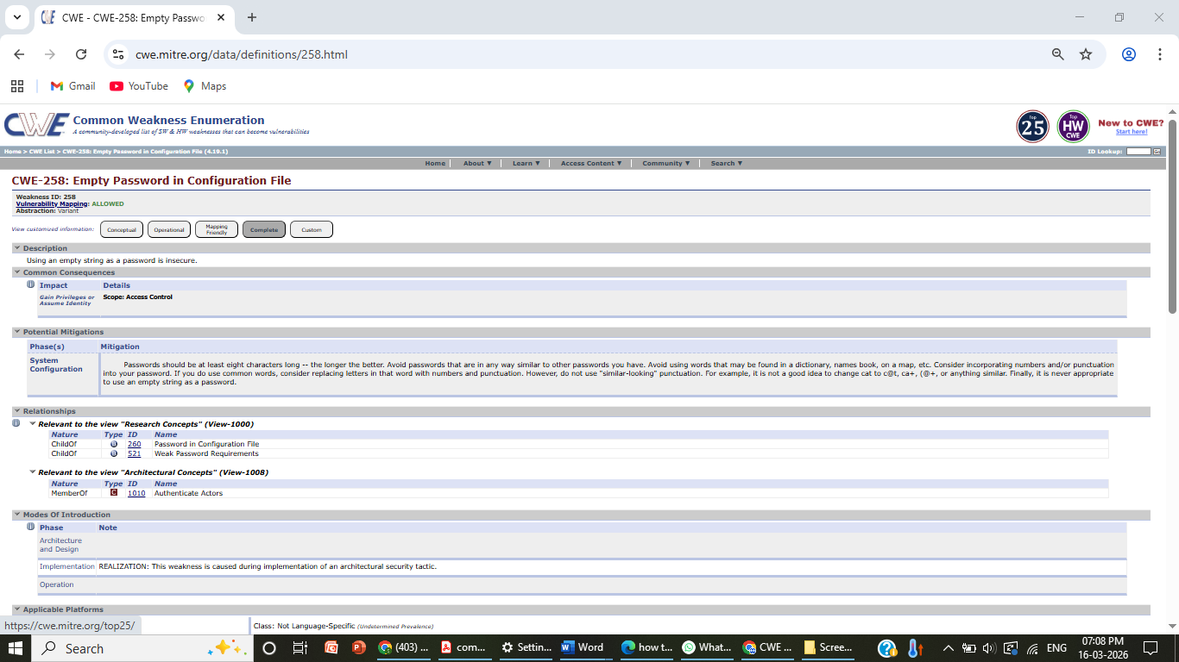

8) Vulnerability Name: Insufficient Verification of Data Authenticity
CWE/CVE: CWE-112

OWASP/SANS Category: A05:2025-Injection

Description:
In a Zero Trust Network Access (ZTNA) environment, applications must verify that all received data comes from trusted and legitimate sources. This vulnerability occurs when an application fails to properly verify the authenticity of data received from users, devices, or external systems. If ZTNA-protected applications do not validate the source and integrity of the data, attackers may send forged or manipulated data to gain unauthorized access or disrupt system operations.

Business Impact:
Insufficient verification of data authenticity can allow attackers to inject false or malicious data into the system. In a ZTNA-based environment, this may lead to unauthorized access, manipulation of sensitive information, and compromise of application security. Such attacks can result in data breaches, operational disruptions, financial losses, and reputational damage to the organization.

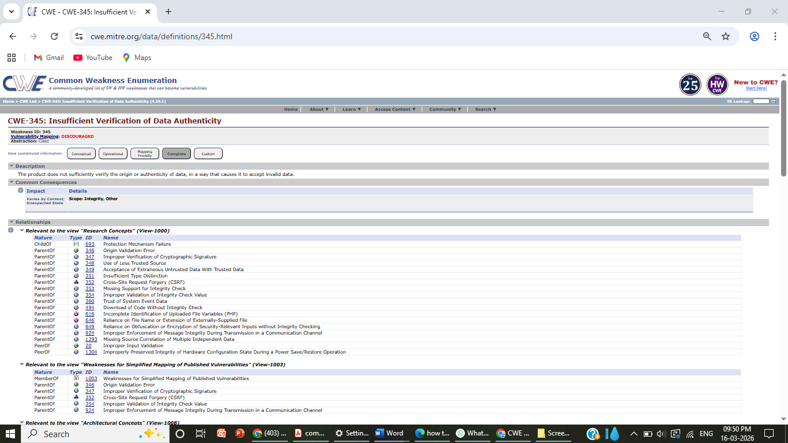

9) Vulnerability Name: Improper Output Neutralization for Logs
CWE/CVE: CWE-304

OWASP/SANS Category: A07:2025-Authentication Failures

Description:
In a Zero Trust Network Access (ZTNA) environment, logging plays an important role in monitoring user activities and detecting security threats. Improper output neutralization for logs occurs when an application records user inputs or system data in log files without properly sanitizing them. If ZTNA-protected applications log unfiltered data, attackers may inject malicious characters or false log entries, which can manipulate log records and hide malicious activities.

Business Impact:
Improper log neutralization can lead to log injection attacks, where attackers modify or forge log entries. In a ZTNA-based system, this may prevent security teams from accurately detecting suspicious activities or security incidents. As a result, attackers may remain undetected, leading to unauthorized access, data breaches, system compromise, and damage to the organization’s reputation.



10) Vulnerability Name: Generation of Error Message Containing Sensitive Information

CWE/CVE: CWE-778

OWASP/SANS Category: A09:2025-Security Logging and Alerting Failures

Description:
In a Zero Trust Network Access (ZTNA) environment, applications should handle error messages carefully to avoid exposing sensitive information. This vulnerability occurs when an application generates detailed error messages that reveal internal system details such as file paths, database queries, server configurations, or authentication information. If ZTNA-protected applications display such information to users, attackers may use it to understand the system structure and exploit other vulnerabilities.

Business Impact:
Error messages containing sensitive information can help attackers gather important details about the
application and its infrastructure. In a ZTNA-based system, this information may assist attackers in
bypassing security controls or targeting specific components of the application. This can lead to
unauthorized access, system compromise, data breaches, and damage to the organization’s reputation.

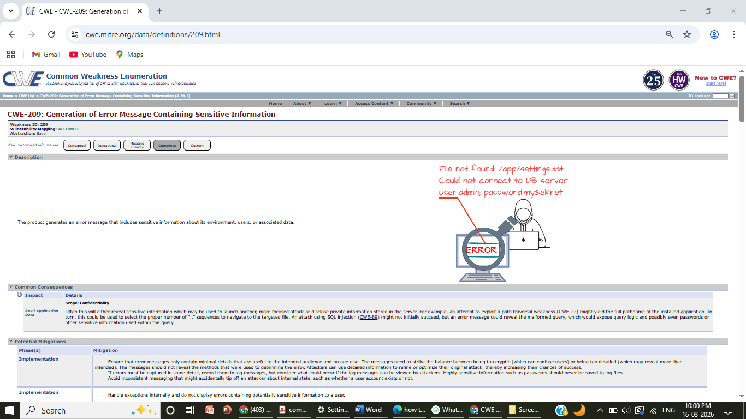

Stage 2

Overview :-

Nessus is a vulnerability scanner developed by Tenable, Inc. It is a remote scanner, meaning
that it does not need to be installed on the target host to scan it. Nessus works by sending a
variety of probes to the target host in order to identify vulnerabilities. These probes can include network traffic, operating system commands, and application requests.

Nessus uses a plugin-based architecture. Plugins are small pieces of code that are designed to
identify specific vulnerabilities. There are over 1200 plugins available for Nessus, covering a
wide range of vulnerabilities in operating systems, applications, and network devices.

When Nessus scans a host, it first uses a discovery plugin to identify the operating system
And services running on the host. Once the host has been discovered, Nessus runs a series of
plugins to test for vulnerabilities. For each vulnerability that Nessus finds, it provides a
detailed report that includes the severity of the vulnerability, the steps to reproduce the
vulnerability, and the steps to remediate the vulnerability.

Nessus can be used to scan a variety of targets, including single hosts, networks, and web
applications. It can also be used to scan specific ports and services. Nessus can be configured
to run scans on a schedule or manually.

Here is a step-by-step explanation of how Nessus works:

- Nessus connects to the target host using a variety of protocols, including TCP, UDP, and ICMP.
- Nessus sends a series of probes to the target host in order to identify its operating system and services.
- Nessus runs a series of plugins to test for vulnerabilities.
- Nessus generates a report that includes the severity of each vulnerability, the steps to reproduce the vulnerability, and the steps to remediate the vulnerability.

Nessus is a valuable tool for security professionals who need to identify and remediate vulnerabilities in their networks. It is easy to use and provides comprehensive reports that can be used to prioritise remediation efforts.

Here are some of the benefits of using Nessus:

  - Comprehensive vulnerability coverage: Nessus has over 1200 plugins available, covering a wide range of vulnerabilities in operating systems, applications, and network
  - Easy to use: Nessus has a user-friendly interface that makes it easy to configure and run scans.
  - Comprehensive reporting: Nessus provides detailed reports that include the severity of each vulnerability ,the steps to reproduce the vulnerability, and the steps to remediate the vulnerability.
  - Scalability: Nessus can be used to scan a variety of targets, including single hosts, networks, and web applications.
  - Flexibility: Nessus can be configured to run scans on a schedule or manually.

Nessus is a powerful tool that can be used to improve the security of any network. It is a
valuable asset for any security professional.

Target website :- http://testfire.net/
Target ip address:- 65.61.137.117

List of Vulnerability:-

s.no | Vulnerability name | Severity | plugins
1 | TLS Version 1.0 Protocol  Detection | MEDIUM | 104743
2 | TLS Version 1.1 Protocol  Deprecated | MEDIUM | 157288
3 | SSL/TLS Diffie-Hellman Modulus  <= 1024 Bits (Logjam) | LOW | 83875
4 | ICMP Timestamp Request Remote  Date Disclosure | INFO | 10114
5 | Additional DNS Hostnames | INFO | 46180
6 | Apache Tomcat Detection | INFO | 39446
7 | Common Platform Enumeration  (CPE) | INFO | 45590
8 | Device Type | INFO | 54615
9 | HSTS Missing From HTTPS Server | INFO | 84502
10 | HTTP Server Type and Version | INFO | 10107

REPORT: -

- Vulnerability Name: - 104743 - TLS Version 1.0 Protocol Detection Severity: - MEDIUM
Plugin: - 104743

Port: - 443
Description: - The remote service accepts connections encrypted using TLS 1.0. TLS 1.0 has a number of cryptographic design flaws. Modern implementations of TLS 1.0 mitigate these problems, but newer versions of TLS like 1.2 and 1.3 are designed against these flaws and should be used whenever possible.
As of March 31, 2020, Endpoints that aren’t enabled for TLS 1.2 and higher will no longer function properly with

major web browsers and major vendors.

PCI DSS v3.2 requires that TLS 1.0 be disabled entirely by June 30, 2018, except for POS POI

terminals (and the SSL/TLS termination points to which they connect) that can be verified as not being

susceptible to any know exploits.

Solution: - Enable support for TLS 1.2 and 1.3, and disable support for TLS 1.0.
Business Impact: -Continued use of TLS 1.0's encryption, known for its inherent cryptographic flaws, exposes the organization to heightened security risks, increasing the likelihood of data breaches and cyberattacks. This vulnerability jeopardizes compliance with industry standards, specifically PCI DSS v3.2, which mandates the complete cessation of TLS 1.0 use. Non- compliance risks regulatory penalties and erodes customer trust. Moreover, endpoints that lack support for TLS 1.2 and higher will experience impaired functionality with major web browsers and vendors, potentially leading to lost business opportunities and damage to the organization's reputation. Addressing this vulnerability is imperative to mitigate these multifaceted risks and maintain a secure and trustworthy online presence.

2)Vulnerability Name: - 157288 - TLS Version 1.1 Protocol Deprecated Severity: - MEDIUM
Plugin: - 157288

Port: - 443
Description: - The remote service accepts connections encrypted using TLS 1.1. TLS 1.1 lacks support for current and recommended cipher suites. Ciphers that support encryption before MAC computation, and authenticated encryption modes such as GCM cannot be used with TLS 1.1 As of March 31, 2020, Endpoints that are not enabled for TLS 1.2 and higher will no longer function properly with major web browsers and major vendors.

Solution: - Enable support for TLS 1.2 and/or 1.3, and disable support for TLS 1.1.

Business Impact: -The continued use of TLS 1.1 with its lack of support for modern cipher suites and advanced encryption methods jeopardizes the organization's security posture, increasing vulnerability to cyber threats and potential data breaches. Additionally, endpoints not upgraded to support TLS 1.2 and higher will encounter compatibility issues with major web browsers and vendors, impacting user experience and potentially leading to missed business opportunities. Swift remediation of this vulnerability is essential to mitigate security risks and ensure seamless interactions with web browsers and vendors, preserving the organization's reputation and operational efficiency.

3)Vulnerability Name: - 83875 - SSL/TLS Diffie-Hellman Modulus <= 1024 Bits (Logjam) Severity: - LOW
Plugin: - 83875

Port: - 443
Description: - The remote host allows SSL/TLS connections with one or more Diffie-Hellman moduli less than or equal to 1024 bits. Through cryptanalysis, a third party may be able to find the shared secret in a short amount of time (depending on modulus size and attacker resources). This may allow an attacker to recover the plaintext or potentially violate the integrity of connections.
Solution: - Reconfigure the service to use a unique Diffie-Hellman moduli of 2048 bits or greater.
Business Impact: - Allowing SSL/TLS connections with weak Diffie-Hellman moduli raises security concerns. An attacker with sufficient resources and computing power could compromise the shared secret relatively quickly, potentially leading to the decryption of sensitive data or the violation of connection integrity. While the severity is low, the risk of data breaches and integrity compromise should not be underestimated, and it is essential to address this vulnerability to maintain data security and user trust.

4)Vulnerability Name: - 10114 - ICMP Timestamp Request Remote Date Disclosure

Severity: - INFO
Plugin: - 10114

Port: - 0
Description: - The remote host answers to an ICMP timestamp request. This allows an attacker to know the date that is set on the targeted machine, which may assist an unauthenticated, remote attacker in defeating time-based authentication protocols.
Timestamps returned from machines running Windows Vista / 7 / 2008 / 2008 R2 are deliberately incorrect, but usually within 1000 seconds of the actual system time.
Solution: - Filter out the ICMP timestamp requests (13), and the outgoing ICMP timestamp replies (14).
Business Impact: -This does not pose an immediate threat to business operations or data security. This vulnerability allows external parties to request the system's date and time information remotely. While it does not present a significant risk, it could potentially be used by attackers for reconnaissance purposes. Therefore, it is advisable to address this vulnerability as part of a broader security posture to reduce the risk of unauthorized data gathering and protect against potential future threats.

5)Vulnerability Name: - 46180 - Additional DNS Hostnames Severity: - INFO
Plugin: - 46180

Port: - 0
Description: - Hostnames different from the current hostname have been collected by miscellaneous plugins. Nessus has generated a list of hostnames that point to the remote host. Note that these are only the alternate hostnames for hosts discovered on a web server.
Different web servers may be hosted on name-based virtual hosts.
Solution: - If you want to test them, re-scan using the special vhost syntax, such as : www.example.com [192.0.32.10]
Business Impact: -This does not pose an immediate threat to business operations or data security. It indicates the discovery of hostnames that are associated with the remote host, particularly in cases of web servers utilizing name-based virtual hosts. While not a security risk on its own, it could be useful for understanding the server's configuration and infrastructure.
Organizations should consider this information as part of their network documentation but do not need to take immediate action to mitigate it as a security threat.

6)Vulnerability Name: - 39446 - Apache Tomcat Detection Severity: - INFO
Plugin: - 39446

Port: - 80
Description: -Nessus was able to detect a remote Apache Tomcat web server.

Solution: - n/a
Business Impact: -Is an informational finding that identifies the presence of a remote Apache Tomcat web server. While this information itself does not indicate a security threat or impact on business operations, it can be useful for network administrators and security professionals to be aware of the technologies in use on their network. Understanding the presence of an Apache Tomcat server can be valuable for maintaining and securing web applications, but it does not require immediate action to mitigate a security risk.

7)Vulnerability Name: - 45590 - Common Platform Enumeration (CPE)

Severity: - INFO
Plugin: - 455

Port: - 0
Description: - By using information obtained from a Nessus scan, this plugin reports CPE (Common Platform Enumeration) matches for various hardware and software products found on a host.
Note that if an official CPE is not available for the product, this plugin computes the best possible CPE based on the information available from the scan.

Solution: - n/a
Business Impact: - This provides insights into hardware and software products identified on a host through a Nessus scan. It reports CPE matches, which are standardized identifiers for these products. This information is valuable for asset management and inventory purposes. While it doesn't signify a security threat, it aids administrators in understanding the components within their network, contributing to effective resource management and facilitating future system maintenance.

8)VulnerabilityName:4559Common Plateform Enumeration(CPE) Severity: - INFO
Plugin: - 54615

Port: - 0
Description: - Based on the remote operating system, it is possible to determine what the remote system type is (eg: a printer, router, general-purpose computer, etc).

Solution: -
Business Impact: - It allows for the identification of the remote system type, such as a printer, router, or general-purpose computer, based on the remote operating system. While this doesn't pose a direct security threat, it offers valuable insights for network administrators to better understand and classify the devices in their network. This information aids in network management, optimization, and ensures that the right security measures are in place for each device type.

9)Vulnerability Name: 84502 - HSTS Missing From HTTPS: -

Server Severity: -INFO
Plugin: - 84502

Port: - 443
Description: - The remote HTTPS server is not enforcing HTTP Strict Transport Security (HSTS). HSTS is an optional response header that can be configured on the server to instruct the browser to only communicate via HTTPS. The lack of HSTS allows downgrade attacks, SSL- stripping man-in-the-middle attacks, and weakens cookie-hijacking protections.
Solution: - Configure the remote web server to use HSTS.
Business Impact: -Indicates that the remote HTTPS server does not enforce HTTP Strict Transport Security (HSTS). HSTS is a crucial security feature that, when configured on the server, instructs web browsers to communicate exclusively via HTTPS, enhancing security. The absence of HSTS potentially exposes the server to downgrade attacks, SSL-stripping man-in-the- middle attacks, and weakens protections against cookie hijacking, posing risks to data confidentiality and user security. Enabling HSTS is essential to ensure a higher level of protection for data transmitted between clients and the server.

10)Vulnerability Name: - 10107 - HTTP Server Type and Version Severity: - INFO
Plugin: - 10107

Port: - 443

Description: - This plugin attempts to determine the type and the version of the remote web server.

Solution: - N/A
Business Impact: -This relates to the identification of the remote web server's type and version. While this issue doesn't pose an immediate security threat, it can provide valuable information to potential attackers about the server's software stack. Knowledge of the server type and version may aid attackers in exploiting known vulnerabilities specific to that software, making it important to restrict such information from being easily accessible to enhance the server's overall security posture.

Stage3

Title: - Title: - Implementing Zero Trust Network Access (ZTNA) with Zscaler: Preventing Unauthorized Access.”

- Zero Trust Network Access (ZTNA)
Zero Trust Network Access (ZTNA) is an IT security framework that provides secure remote access to an organization's internal applications and data based on clearly defined access control policies. Unlike traditional Virtual Private Networks (VPNs), which grant users broad access to the entire network, ZTNA operates on a "never trust, always verify" principle. It grants users access only to the specific applications they need, and only after their identity and device have been verified.
ZTNA is a critical component of modern security architecture. It helps organizations move away from the concept of a trusted internal network and an untrusted external network (the "castle- and-moat" model). By hiding the internal network from the internet and establishing one-to-one, encrypted connections between users and applications, ZTNA drastically reduces the attack surface and stops common threats like lateral movement by attackers.
- The ZTNA Access Cycle
The ZTNA cycle is a continuous process of verifying identity, establishing secure connections, and enforcing policy for every access request. It typically consists of the following steps:
- User Request: A user, from any location (office, home, coffee shop), requests access to a specific internal application (e.g., an HR portal, a finance server, or an internal code.

- Identity and Device Verification: Before any connection is established, the ZTNA solution verifies who the user is (via multi-factor authentication, or MFA) and checks the security posture of their device. This includes ensuring the device has up-to-date antivirus, a healthy firewall, and is not compromised.
- Policy Enforcement: The ZTNA solution checks the access policy. Does this specific user, with this specific device, have permission to access the requested application at this specific time?
- Establish Secure Connection: If the policy allows access, the ZTNA solution creates a highly secure, encrypted micro-tunnel between the user's device and the target application. Crucially, the user never gains access to the underlying network, only to the application itself.
- Continuous Monitoring: The ZTNA solution continues to monitor the connection for anomalies. If the user's behavior becomes suspicious or their device posture changes, the connection can be terminated in real-time.
- Logging and Analytics: All access attempts, successful and failed, are logged and analyzed. This data is used for auditing, threat hunting, and refining access policies.

  - Zscaler (Zscaler Internet Access / Zscaler Private Access)
Zscaler is a cloud-native security platform that delivers its services entirely from the cloud, eliminating the need for on-premises hardware like VPN concentrators. For ZTNA, Zscaler offers Zscaler Private Access (ZPA) . ZPA is a service that provides seamless, identity-based access to private applications without ever placing users on the network.
Zscaler ZPA operates on a simple principle: the application is "inside" the Zscaler cloud, and the user connects to it there. It collects data from a variety of sources, including:
- Identity Providers (IdP): Such as Azure AD, Okra, or Ping Identity, to verify user identities.
- Device Posture Partners: Such as CrowdStrike, Tanium, or Microsoft Defender for Endpoint, to check the health of the endpoint.
- Business Applications: The internal web apps, file servers, and legacy applications hosted in data centers or public clouds (e.g., AWS, Azure).
- Zscaler App Connectors: Lightweight software components deployed in the data center or cloud that initiate outbound connections to the Zscaler cloud, making internal servers invisible to the internet

Zscaler then enforces policies based on this data, including:
- Identity-Based Access: Policies are built around user and group identities, not IP addresses.
- Application Segmentation: Users are granted access to specific applications, not entire subnets.
- Least Privilege Access: Ensures users have the minimum level of access required to perform their jobs.

The Zscaler ZTNA Cycle
The Zscaler ZTNA cycle is the practical application of the ZTNA principles using the Zscaler cloud. The cycle typically consists of the following steps:
- User Login and Authentication: A user attempts to access an internal application. They are redirected to their organization's Identity Provider (IdP) for authentication and MFA.
- Device Posture Check (Integration): Zscaler checks with integrated endpoint protection tools to ensure the device is compliant with security policies.
- Policy Lookup and Decision: The Zscaler cloud evaluates the request against the defined access policies. It verifies that the user, device, and context (time, location) are authorized for that specific application.
- Establishing the Micro-tunnel: Once authorized, the Zscaler cloud instructs the user's Zscaler Client Connector and the appropriate Zscaler App Connector in the data center to establish an encrypted connection. The user is now connected to the application.
- Traffic Inspection (Optional): For sanctioned applications, Zscaler can optionally inspect the traffic for data loss prevention (DLP) or to detect malware.
- Logging and Analytics: All activity is logged in the Zscaler cloud portal for reporting, threat hunting, and compliance.

MISP (Malware Information Sharing Platform) Integration
While Zscaler is a primary access control tool, it can be enhanced by integrating with threat intelligence platforms like MISP.
- Threat Intelligence Feed: MISP can aggregate and share threat intelligence about malicious domains, IPs, and URLs. This list of indicators of compromise (IOCs) can be fed into Zscaler's cloud.
- Proactive Blocking: If a user, even one authorized by ZPA, attempts to access a known malicious site that has been flagged by the MISP feed, Zscaler Internet Access (ZIA) can block the request, preventing a potential infection.
- Enhanced Visibility: Security teams can use MISP to cross-reference Zscaler logs. If a user's behavior is anomalous, the team can check MISP to see if the destination IP or domain is associated with a known threat actor or campaign.
  - Your College Network Information
This infrastructure presents a large attack surface, especially with the need for remote learning and
administrative access. The network includes:

- Core routers and switches
- Distribution routers and switches
- Wireless access points
- Firewalls and Intrusion Detection Systems (IDS)
- Internal Application Servers: Hosting the student information system, library resources, research data repositories, and administrative portals.
- Legacy VPN Concentrator: Currently providing broad network-level access for faculty and staff working remotely.
The need for ZTNA arises from the limitations of the current VPN model:
- Over-permissioned Access: Once on the VPN, a faculty member's compromised laptop could potentially scan and attack the entire internal network (lateral movement).
- Hidden Applications: Some research applications need to be accessed by external collaborators without granting them full network access.
- User Experience: The legacy VPN can be slow and cumbersome, often requiring users to route all their internet traffic through the university.
  - How you think you deploy ZTNA using Zscaler in your college
To deploy Zscaler ZTNA (ZPA) in your college, you would start by identifying the specific applications that need to be secured and the user groups that need access to them. This is a shift from securing the network to securing access to applications.

The plan would need to include the following:
- Application Discovery: Catalog all internal applications (e.g., ERP, library system, research servers, file shares) and identify which ones are currently exposed via the VPN.
- User Segmentation: Define user groups (e.g., Students, Faculty - Research, Faculty - Admin, IT Staff, External Collaborators) and the specific applications each group needs.
- Deploying Zscaler App Connectors: Install lightweight App Connector VMs in the university's data center. These connectors will establish outbound connections to the Zscaler cloud, making the application servers invisible to the public internet.
- Integrating Identity Provider: Connect Zscaler to the university's existing Identity Provider (e.g., Microsoft Azure AD) to leverage current usernames, passwords, and MFA policies.
- Configuring Access Policies: Create granular policies in the Zscaler admin portal. For example: "The 'Faculty' group can access the 'ERP Application' from any device that has antivirus enabled, after MFA."

- Deploying Zscaler Client Connector: Students, faculty, and staff will install the Zscaler Client Connector on their laptops and mobile devices. This small client intelligently routes traffic for private applications through ZPA and public traffic through ZIA.

Thread Intelligence
In the context of Zscaler and ZTNA, threat intelligence is used to understand who is trying to access what, and from where. It helps move beyond simple identity checks to a more contextual understanding of risk.
Sources include:
- Zscaler Cloud Logs: Internal logs provide real-time data on who is accessing which applications, from which locations, and on what devices.
- External Threat Feeds (MISP): Information about new malware campaigns, phishing kits, or command-and-control servers being used by attackers.
- Identity Provider Logs: Anomalies in login attempts, such as a user logging in from two geographically impossible locations in a short time, can signal a compromised account.
This intelligence is used for:
- Adaptive Access Control: If threat intelligence suggests a user's location is high-risk, Zscaler can step-up authentication requirements or block access entirely.
- Hunting for Compromised Accounts: Analysts can use Zscaler logs to see if a user is suddenly accessing applications they never have before, which could be a sign of credential theft.
- Blocking Malicious Communication: Threat intelligence feeds can be used by Zscaler Internet Access (ZIA) to block outbound connections to known malicious sites, even if they originate from a user inside the university.

Incident Response (Adapted for ZTNA)
Incident response in a ZTNA model is faster and more targeted because the environment is inherently more controlled.
- Detection: The SOC team detects an anomaly. For example, a faculty account is downloading an unusually high volume of data from a research server at 3 AM. Zscaler logs provide the exact details: the user, the device, the application, and the amount of data transferred.
- Containment: The SOC team can instantly isolate the user. In the Zscaler portal, they can simply deactivate that user's access or block their specific device. Because there is no network- level access, this action immediately severs all connections to every application, preventing lateral movement.
- Eradication: The compromised device is taken offline for malware scanning and cleaning by the IT helpdesk.
- Recovery: Once the device is clean and the user's password is reset, the Zscaler policy is re- enabled, granting the user access again.
- Post-incident review: The security team analyzes the logs to understand how the account was compromised (e.g., a phishing email) and updates Zscaler policies, perhaps by adding a block for similar malicious domains or tightening access rules for that specific research application.

Benefits of this incident response approach:
- Near-Instant Containment: Actions take seconds in a cloud dashboard, not minutes or hours configuring firewall rules.
- No Lateral Movement: The attacker is contained to the single compromised application, protecting the rest of the university's network.
- Granular Forensics: Zscaler provides a detailed audit trail of every connection, making investigations faster and more accurate.
- Compliance: This model helps demonstrate compliance with data protection regulations by proving that access to sensitive student or research data is tightly controlled and audited.

Understanding about the tool (Zscaler ZPA)
Zscaler Private Access (ZPA) is a cloud service that embodies the ZTNA principle of "connect a user to an app, not the network." Here are the key things to understand:
- It is "Application-Centric," Not "Network-Centric": You define policies based on applications (e.g., "SAP Server 01"), not network constructs like IP subnets. This aligns security with how businesses actually operate.
- It Hides the Network: ZPA uses App Connectors inside your data center that only
make outbound connections to the Zscaler cloud. Your internal servers never need to open inbound firewall ports, making them invisible to port scanners and attackers on the internet.
- It uses a "Dark Cloud" Approach: To an external scanner, the organization's applications simply don't exist. They only become visible to authorized users after a multi-step verification process.
- It Provides a Superior User Experience: Users don't have to mess with clunky VPN clients. The Zscaler Client Connector works silently in the background. For web apps, access can even be agentless, requiring only a modern browser.
- It is Inherently Scalable: Because it's a cloud service, ZPA scales instantly to handle thousands of concurrent users, unlike a legacy VPN appliance that needs to be manually upgraded.

Conclusion: -

In conclusion, exploring the realm of AI for web security using IBM QRadar has been an insightful journey through various stages.

In Stage 1, understanding web application testing unveiled the critical importance of assessing vulnerabilities and ensuring the security of web-based systems. This foundational knowledge served as a cornerstone for comprehending the subsequent stages.

Stage 2 delved into the intricacies of Nessus reports, emphasising the significance of detailed vulnerability assessments. Analysing these reports provided valuable insights into potential threats, enabling informed decision-making for robust security measures.

Stage 3 introduced the pivotal concept of Zero Trust Network Access (ZTNA) and its implementation using
Zscaler Private Access (ZPA). It demonstrated a paradigm shift from traditional VPN-based network access to
secure, identity-based user-to-application connectivity. The solution showcased the power of hiding internal
applications from the internet, enforcing granular access policies, and eliminating lateral movement. This
underscores the need for modern, proactive cybersecurity strategies in an era of remote work and cloud adoption
Considering the future scope, Stage 1 illuminated the evolving landscape of web application testing. With advancements in AI, there is a promising avenue for more sophisticated testing methodologies, ensuring even higher levels of security for web applications.

Stage 2 highlighted the future trajectory of the testing process, indicating a shift towards more automation and integration of AI-driven tools. This evolution promises quicker, more accurate vulnerability assessments, enhancing overall cybersecurity postures.

Stage 3 illuminated the future potential of Zero Trust Network Access (ZTNA) and Zscaler technologies. With AI integration and machine learning, these systems are poised to become more intelligent and adaptive, enabling real-time risk assessment based on user behavior and device posture. Enhanced automation in policy enforcement, predictive analytics for threat detection, and improved scalability are anticipated, empowering organizations to stay ahead of sophisticated cyber threats in an increasingly distributed world.

In essence, the project not only provided a deep understanding of the current state zero trust
using ZSCALER but also offered a glimpse into the exciting future of cybersecurity.
Embracing these advancements will be crucial for organisations aiming to fortify their digital
landscapes in the face of ever-evolving cyber threats.

Future Scope: -

Future of web application testing

The future of WAT is bright, as web applications become increasingly complex and sophisticated. Organizations are increasingly reliant on web applications to conduct business, and they need to be confident that their web applications are secure and reliable.

Here are some of the key trends that are expected to shape the future of WAT:

- Increased focus on security: Security is a top priority for all organizations, and WAT is essential for identifying and mitigating security vulnerabilities. In the future, we can expect to see even more emphasis on security testing, as web applications become increasingly targeted by cyberattacks.
- Rise of artificial intelligence (AI) and machine learning (ML): AI and ML are already being used in WAT, and their role is expected to grow in the future. AI and ML can be used to automate repetitive tasks, such as test case generation and execution. They can also be used to identify complex patterns and anomalies that may be difficult to detect with traditional testing methods.
- Shift to cloud-based testing: More and more organizations are moving their web applications to the cloud. This trend is driving the growth of cloud-based WAT platforms. Cloud-based testing platforms offer a number of advantages, such as scalability, flexibility, and cost-effectiveness.
- Increased focus on user experience (UX) testing: UX testing is essential for ensuring that web applications are easy to use and meet the needs of users. In the future, we can expect to see more focus on UX testing, as organizations increasingly recognize the importance of providing a positive user experience.

Future scope of the testing process

The future scope of the testing process is bright, as software becomes increasingly complex and sophisticated. Organisations are increasingly reliant on software to conduct business, and they need to be confident that their software is high-quality and reliable
Here are some of the key trends that are expected to shape the future of the testing process:

- Increased focus on continuous testing: Continuous testing is a methodology that involves testing software throughout the SDLC, from development to deployment. This helps to identify defects early and prevent them from causing problems later in the development process.
- Rise of AI and ML: AI and ML are already being used in the testing process, and their role is expected to grow in the future. AI and ML can be used to automate repetitive tasks, such as test case generation and execution. They can also be used to identify complex patterns and anomalies that may be difficult to detect with traditional testing methods.
- Shift to cloud-based testing: Cloud-based testing platforms offer a number of advantages, such as scalability, flexibility, and cost-effectiveness. This is driving the growth of cloud-based testing platforms.
- Increased focus on testing automation: Testing automation is the use of software to execute test cases without human intervention. Testing automation can help to save time and resources, and it can also help to improve the quality and efficiency of testing.

Future scope of SOC / SEIM:-

The future scope of Zero Trust Network Access (ZTNA) and the broader Zero Trust framework is poised for significant evolution, driven by emerging technologies and changing threat landscapes:
- AI-Driven Zero Trust (AI-ZTA): Future Zero Trust implementations will leverage advanced AI and deep learning to move beyond static policies. Systems will continuously learn user behavior, predict anomalous activities before they occur, and dynamically adjust access privileges in real-time based on contextual risk, creating a truly "adaptive" security posture.
- Integration with Edge Computing and IoT: As organizations deploy more IoT devices and edge computing nodes, Zero Trust principles will extend to these resource-constrained environments. Expect the development of lightweight Zero Trust agents and protocols that can authenticate and secure machine-to-machine (M2M) communication at the edge, preventing large-scale botnet attacks.
- Identity-Centric Everything: The future will see identity become the ultimate security perimeter. Zero Trust will evolve to incorporate advanced identity verification methods, including continuous behavioral biometrics (keystroke dynamics, gait analysis)
and decentralized identity solutions using blockchain, ensuring that the user behind the session is verified at all times.
- Convergence with SASE Architecture: Zero Trust will be a core component of the Secure Access Service Edge (SASE) framework. This convergence will provide organizations with a unified, cloud-delivered stack that combines ZTNA, Secure Web Gateways (SWG), Cloud Access Security Brokers (CASB), and Firewall-as-a-Service (FWaaS), simplifying management and ensuring consistent security for all users, regardless of location.
- Zero Trust for Operational Technology (OT) and Critical Infrastructure: Sectors like energy, manufacturing, and healthcare will increasingly adopt Zero Trust to protect critical infrastructure. Future scope includes air-gapped Zero Trust solutions and specialized protocols designed to secure legacy industrial control systems (ICS) and SCADA environments from nation-state attacks.
- Automated Threat Hunting and Response: Future Zero Trust platforms will integrate with Security Orchestration, Automation, and Response (SOAR) tools to enable automated threat hunting. Upon detecting a compromised identity or device, the system will not just block access but automatically initiate investigation playbooks, isolate affected systems, and even roll back malicious changes.

Topics explored: -

Data Collection and Aggregation, Standardization and Normalisation, Enrichment and Analysis, Sharing and Distribution, Integration with Security Tools, Customization and Flexibility, Automation and Orchestration, Community Involvement, Incident Response Support, Threat Intelligence Feeds, Soc and Siem

Tools explored: -

Nmap, Metasploit, Nessus, Kali Linux, OWASP ZAP, Burp Suite

THE END

